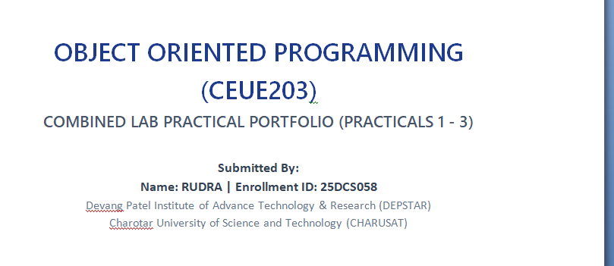 | 

WEB DEVELOPMENT FRAMEWORKS
(ITUE203)
COMBINED LAB PRACTICAL PORTFOLIO (PRACTICALS 1 - 2)
- DESIGN LAYOUTS & BROWSER OUTPUTS -
Submitted By:
Name: RUDRA | Enrollment ID: 25DCS058
Devang Patel Institute of Advance Technology & Research (DEPSTAR)
Charotar University of Science and Technology (CHARUSAT)

1. Project Site Sitemap Diagram
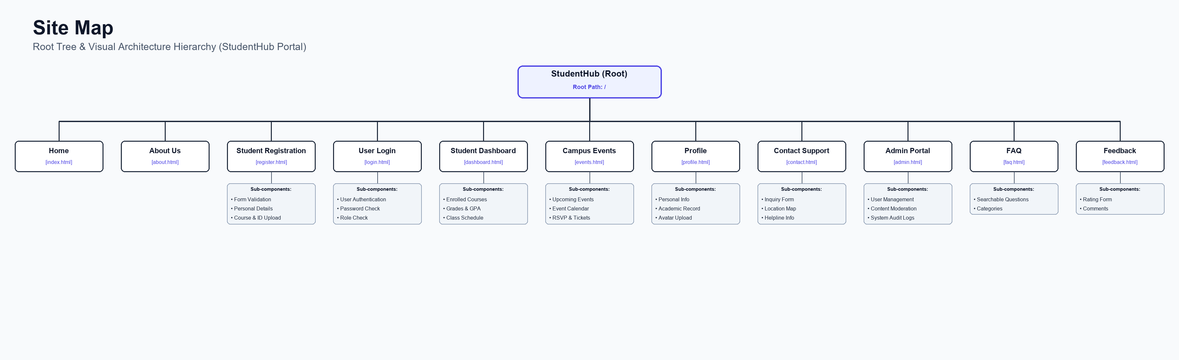
Figure: High-Resolution Visual Sitemap Hierarchy

2. Individual Page Wireframes

Wireframe - Home Page (index.html)
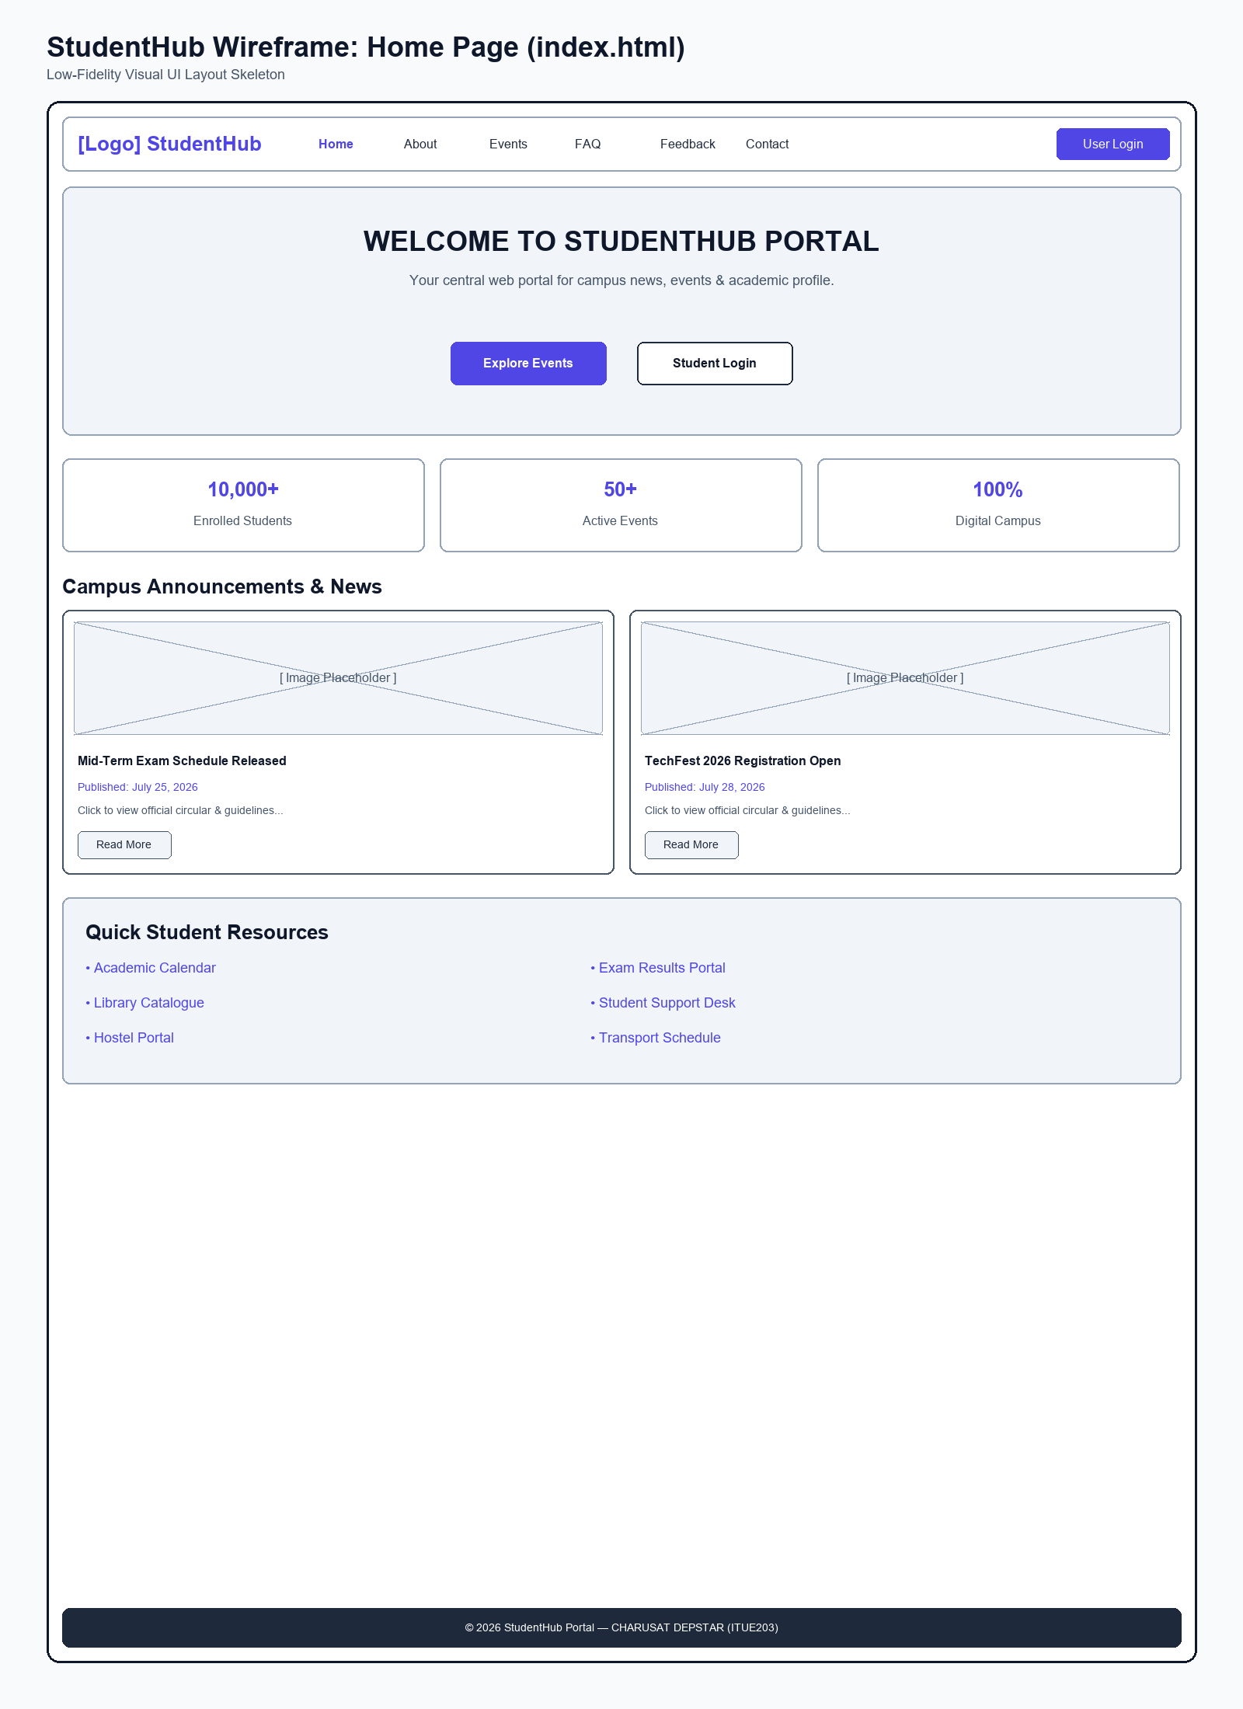
Figure: Wireframe blueprint layout for Home Page

Wireframe - About Us Page (about.html)
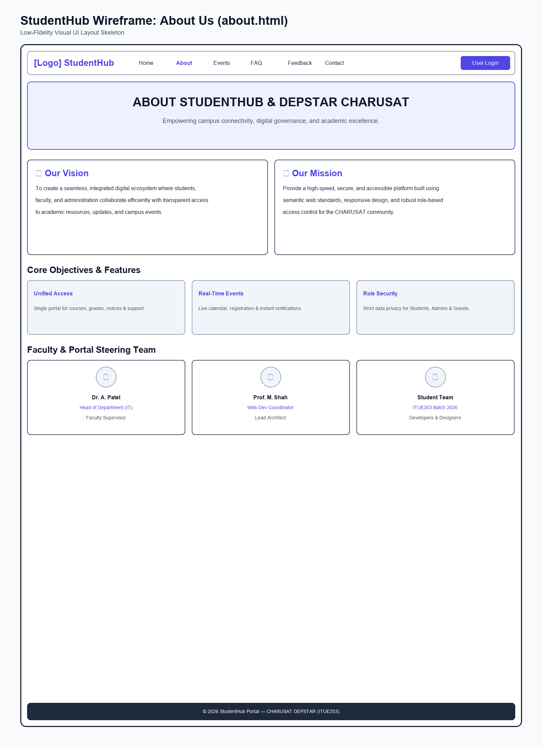
Figure: Wireframe blueprint layout for About Us Page

Wireframe - Student Registration Page (register.html)
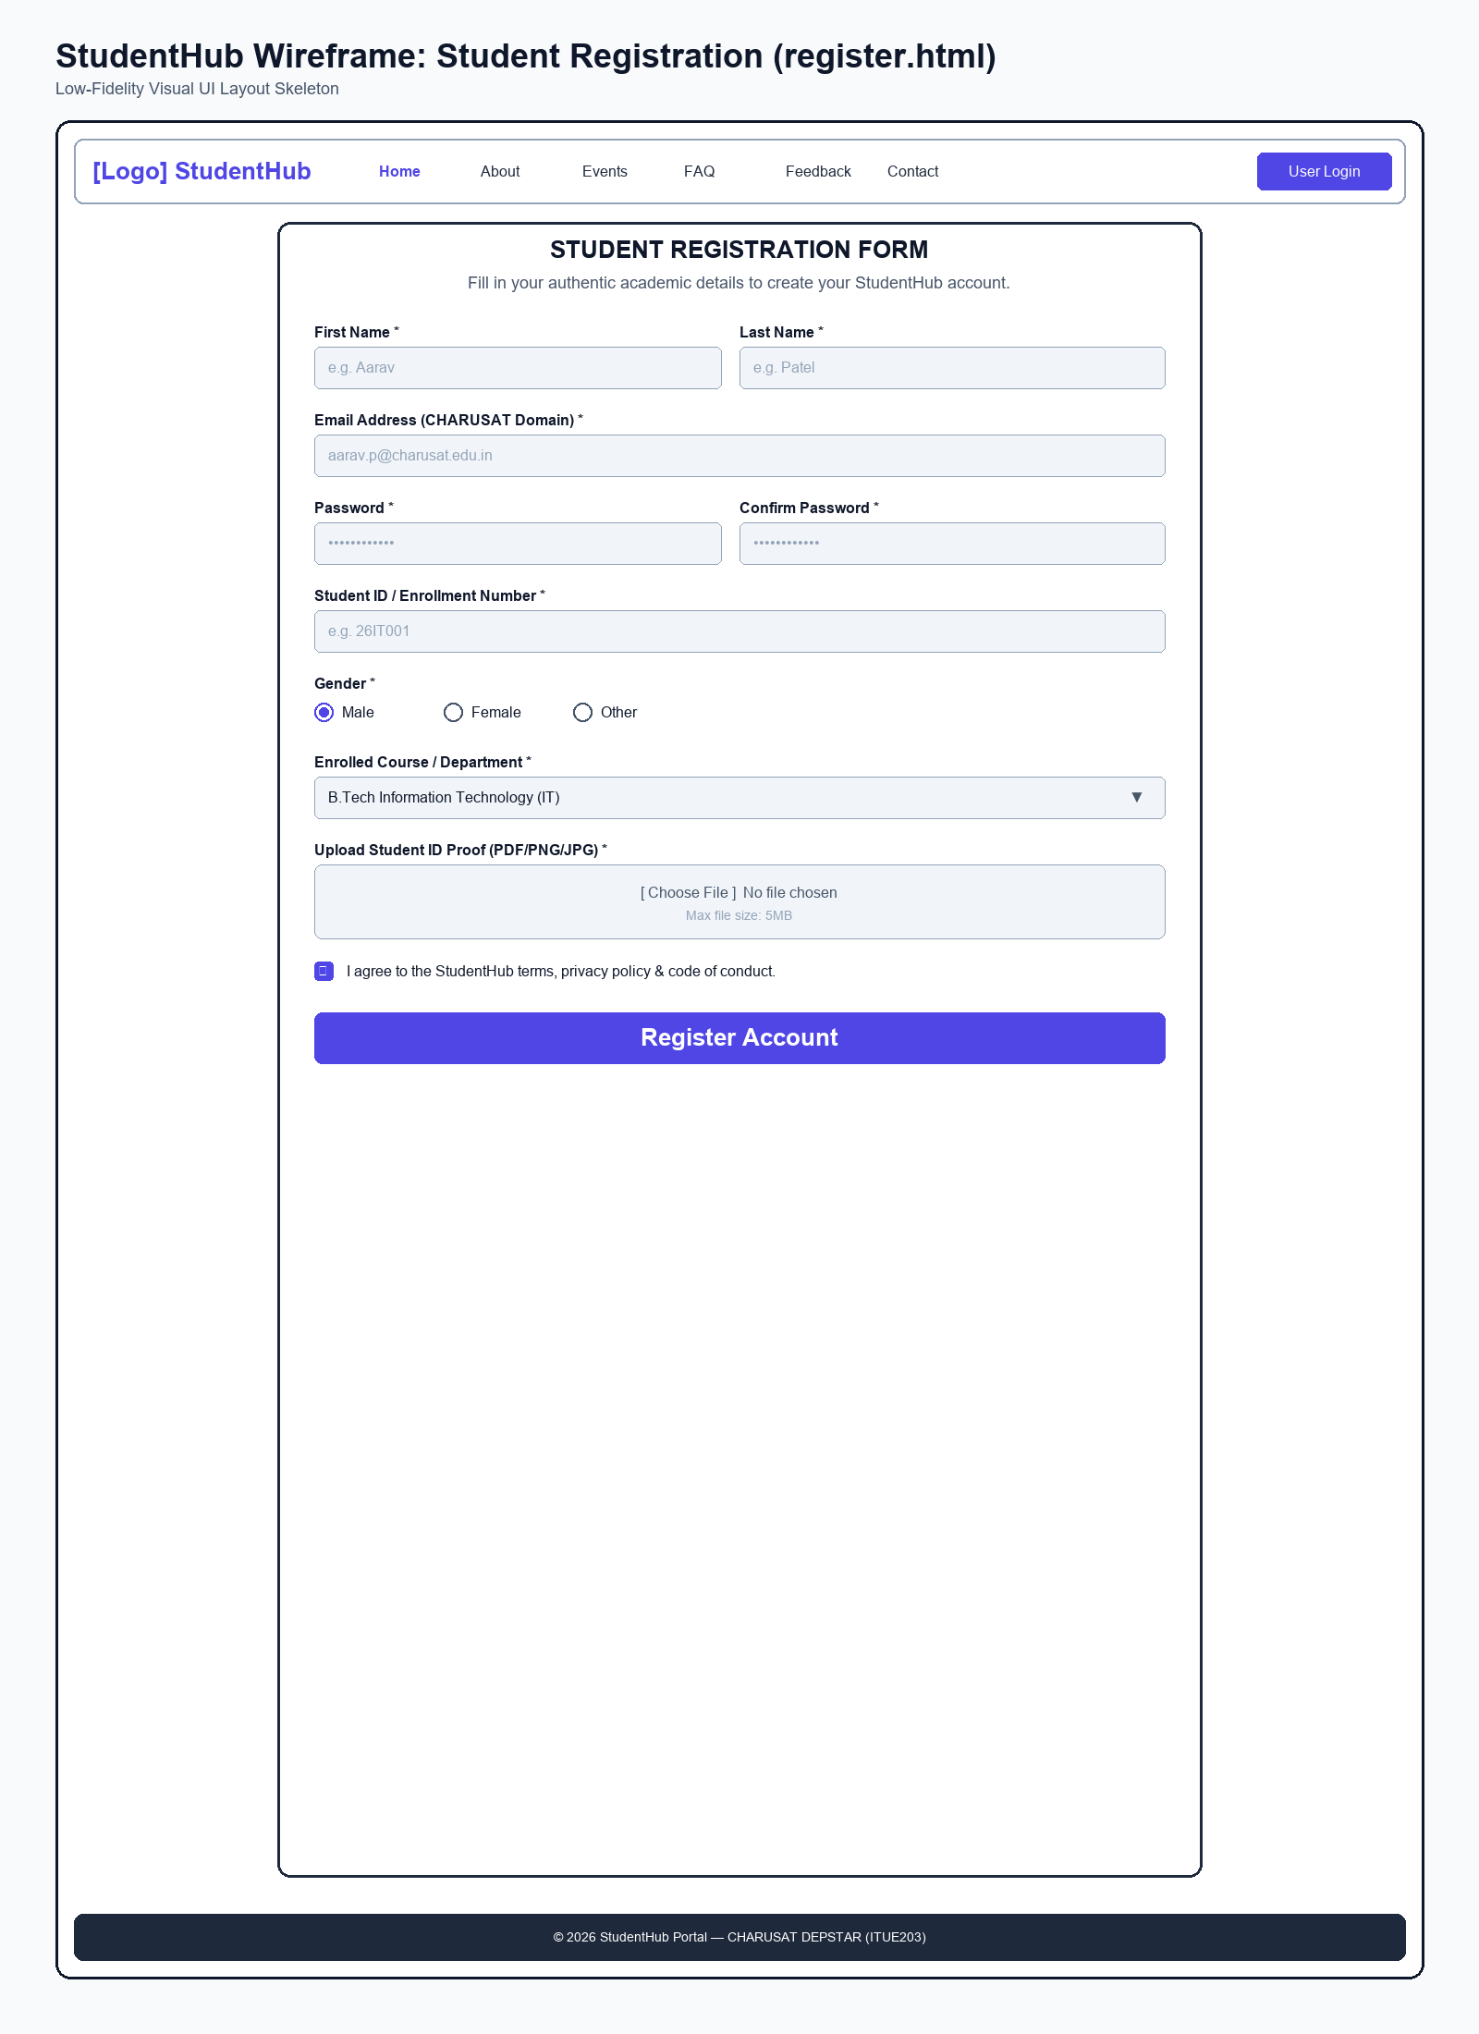
Figure: Wireframe blueprint layout for Student Registration Page

Wireframe - User Login Page (login.html)
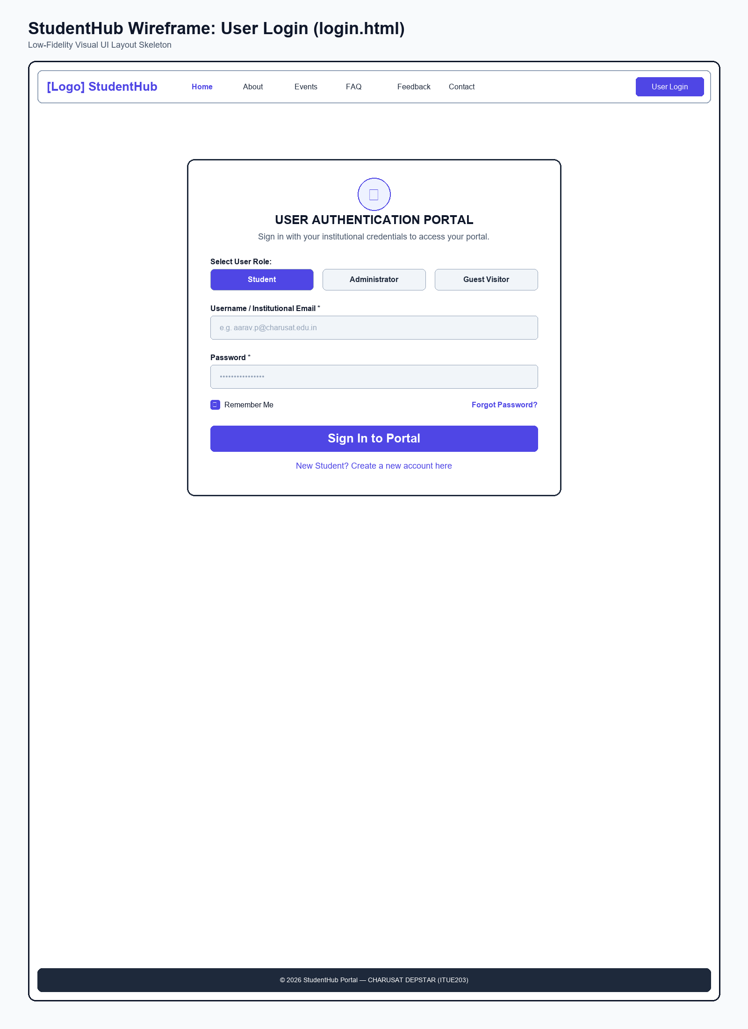
Figure: Wireframe blueprint layout for User Login Page

Wireframe - Student Dashboard Page (dashboard.html)
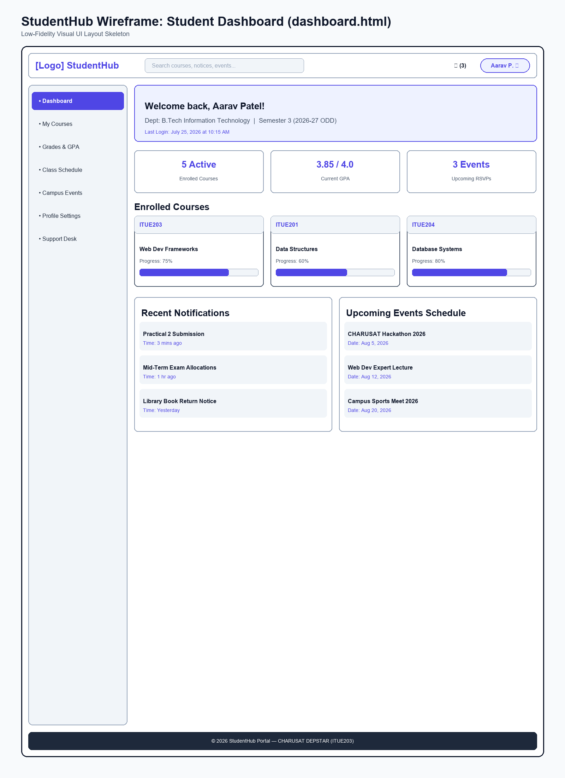
Figure: Wireframe blueprint layout for Student Dashboard Page

Wireframe - Campus Events Page (events.html)
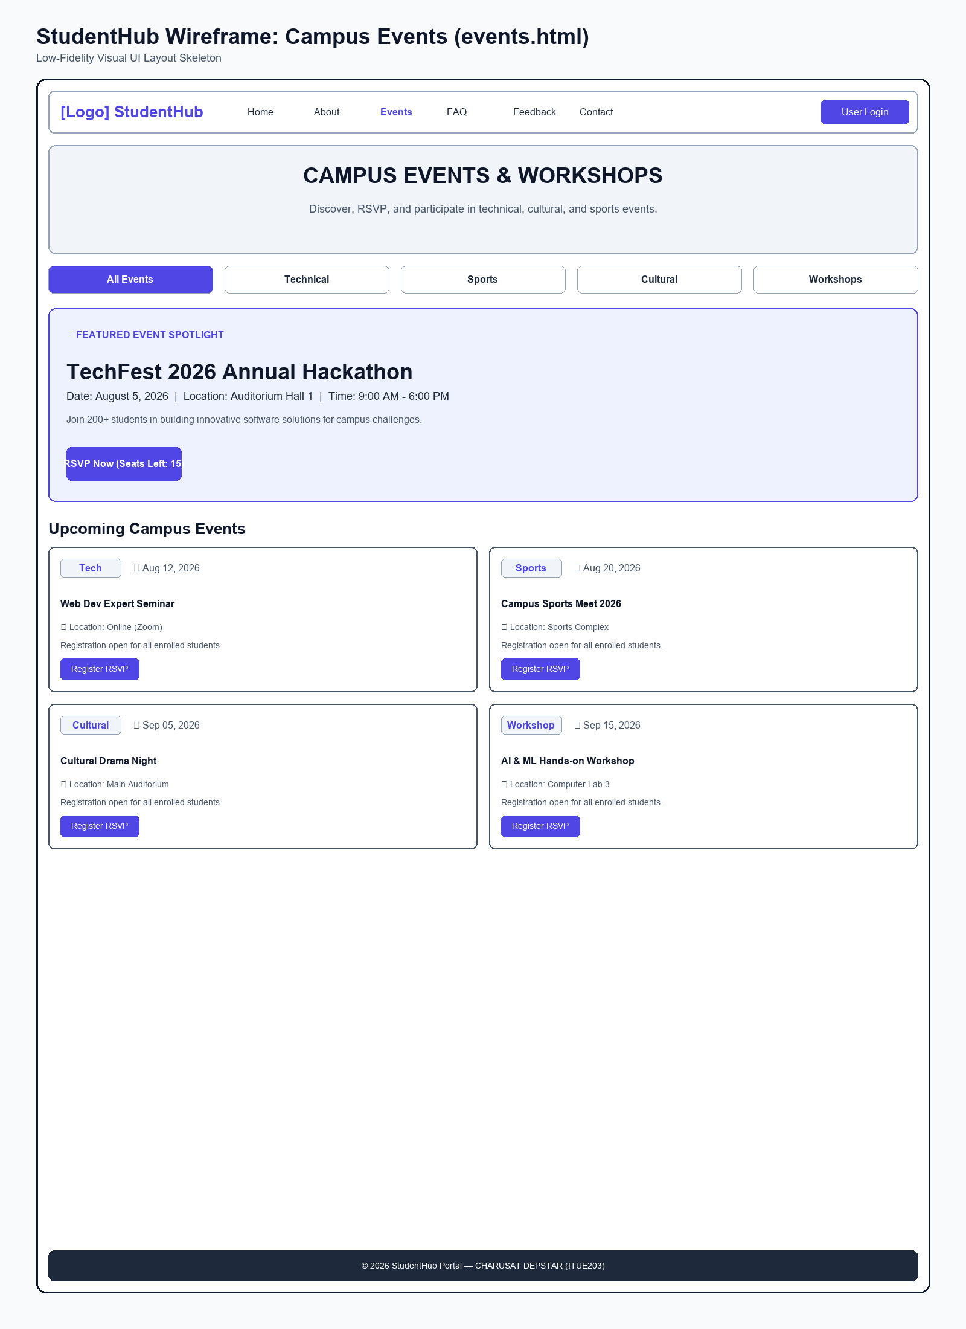
Figure: Wireframe blueprint layout for Campus Events Page

Wireframe - Student Profile Page (profile.html)
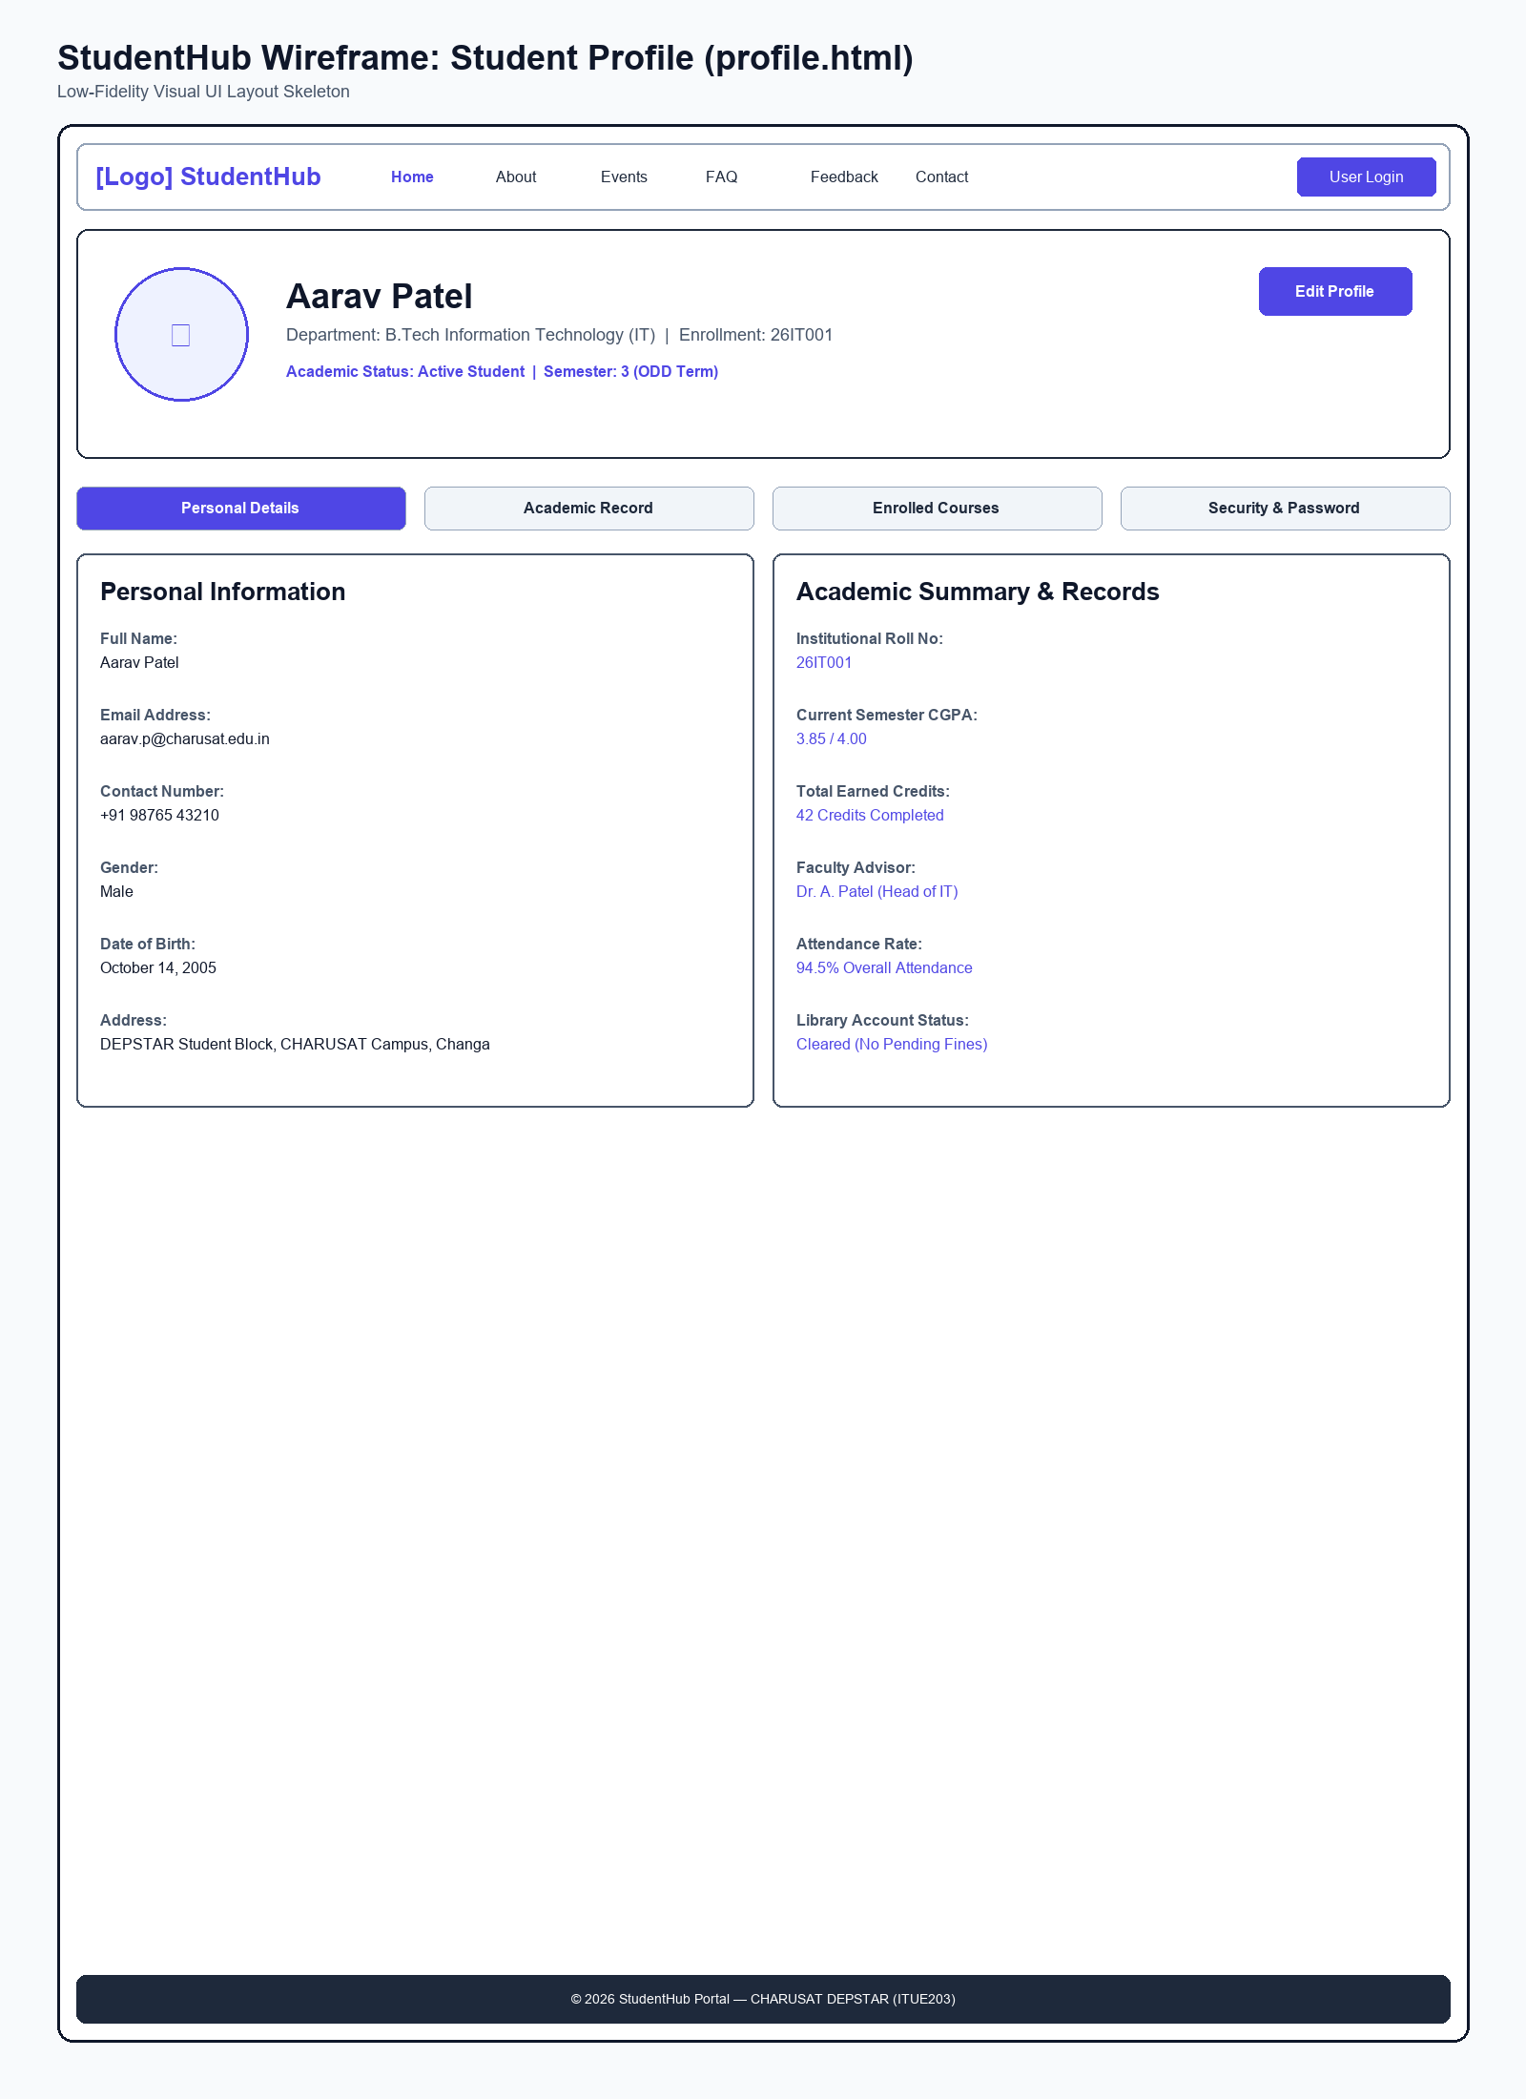
Figure: Wireframe blueprint layout for Student Profile Page

Wireframe - Contact Support Page (contact.html)
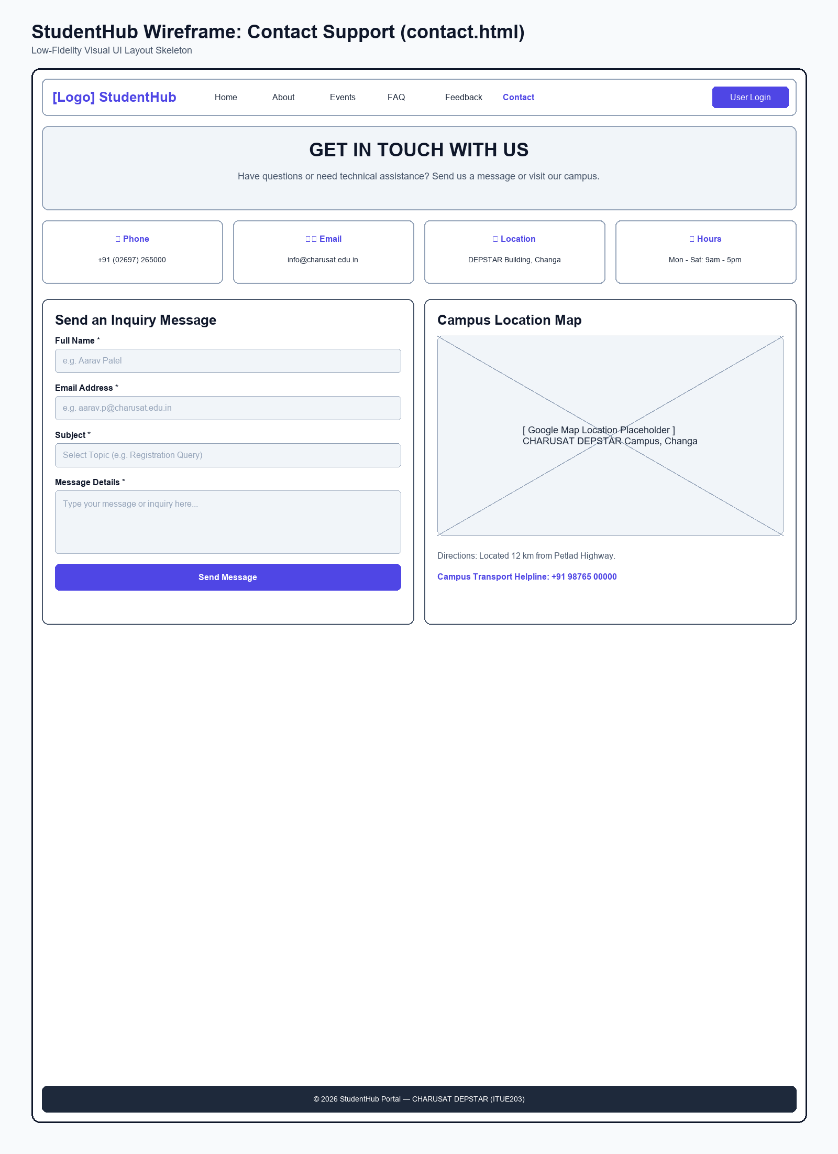
Figure: Wireframe blueprint layout for Contact Support Page

Wireframe - Admin Portal Page (admin.html)
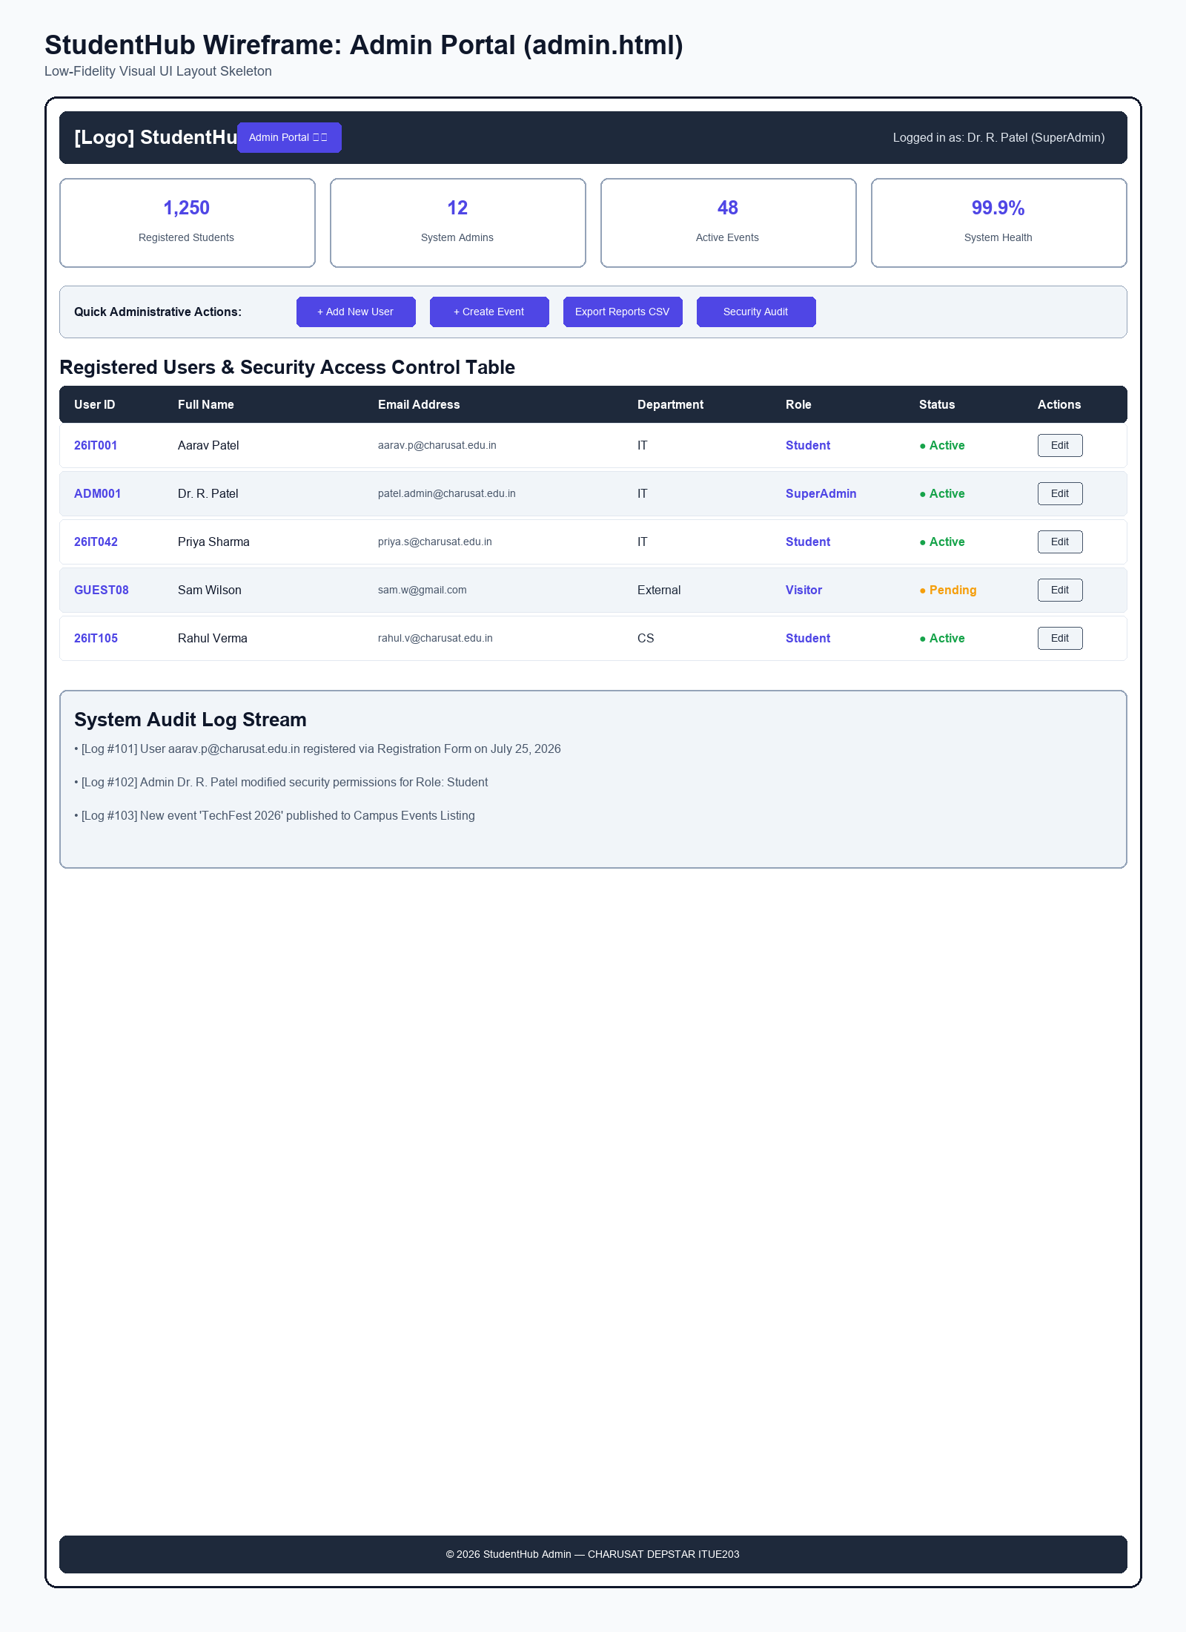
Figure: Wireframe blueprint layout for Admin Portal Page

Wireframe - FAQ Page (faq.html)
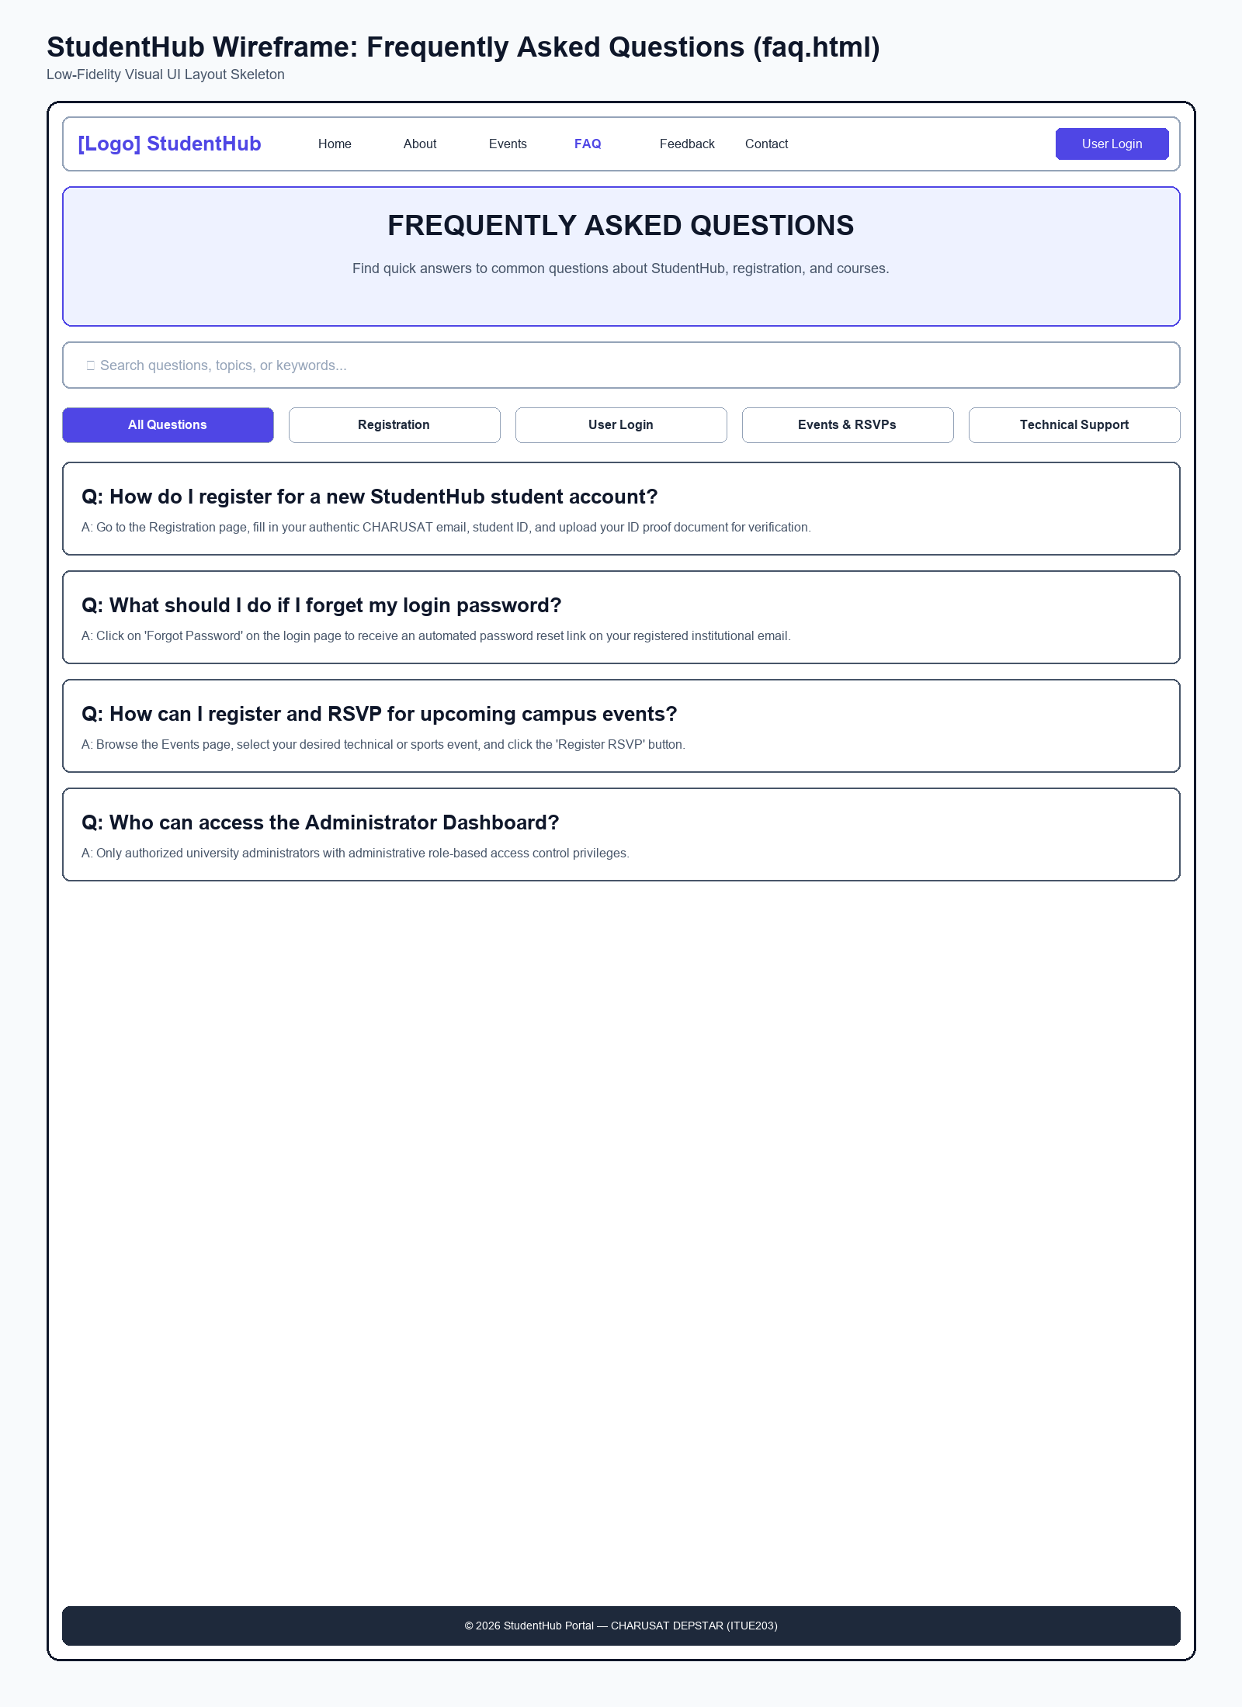
Figure: Wireframe blueprint layout for FAQ Page

Wireframe - Feedback Survey Page (feedback.html)
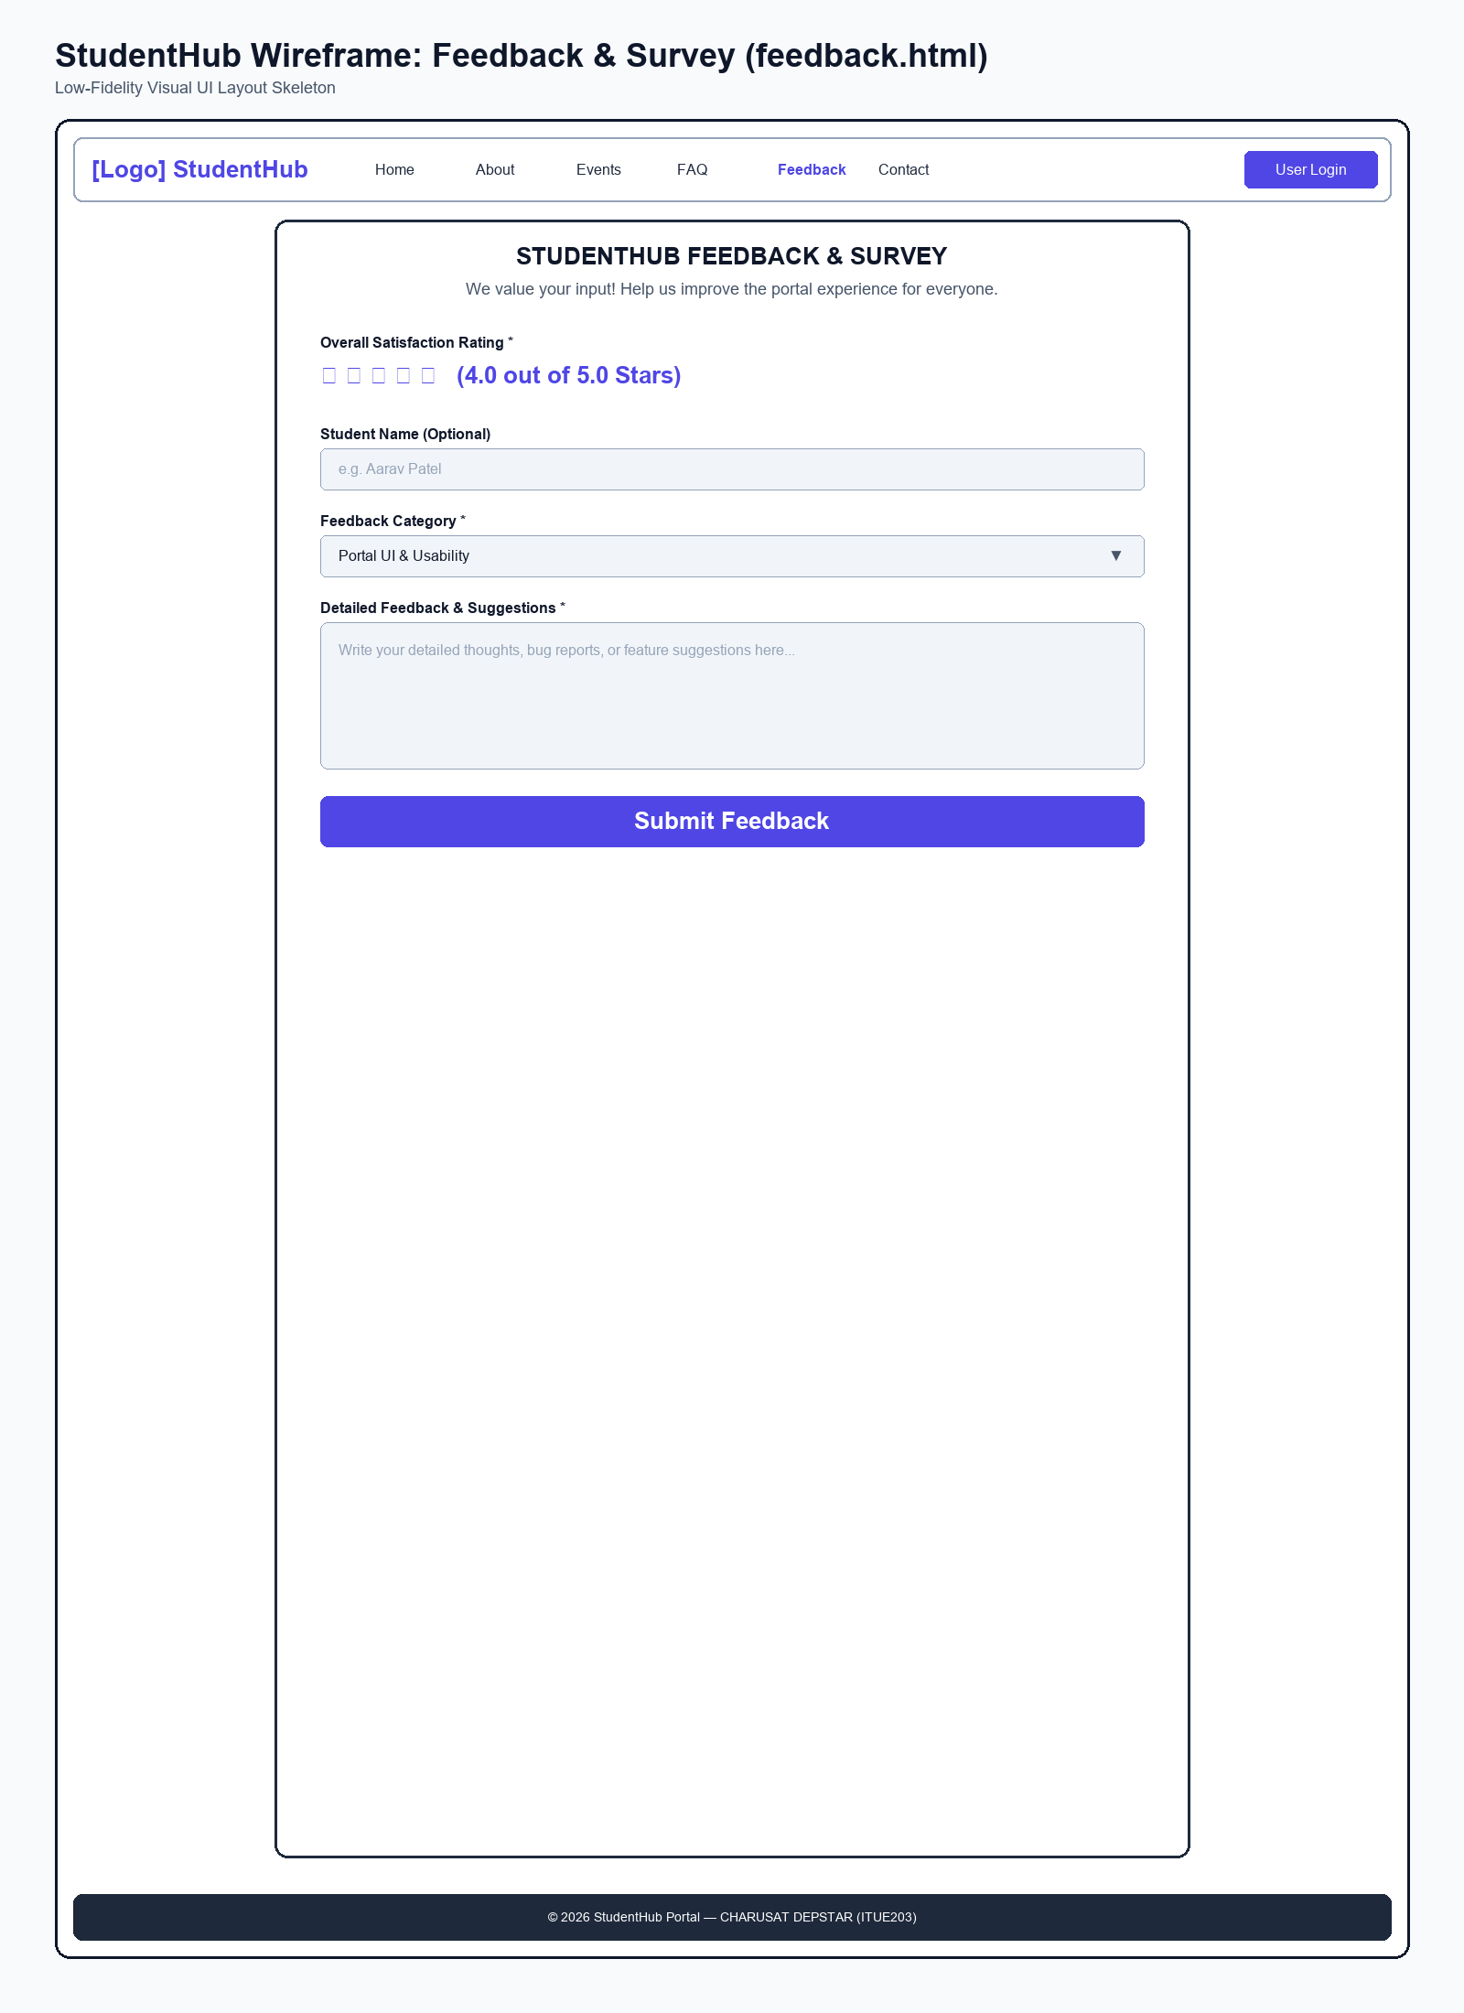
Figure: Wireframe blueprint layout for Feedback Survey Page

3. Browser Webpage Output Screenshots

Webpage Output - Home Page (index.html)
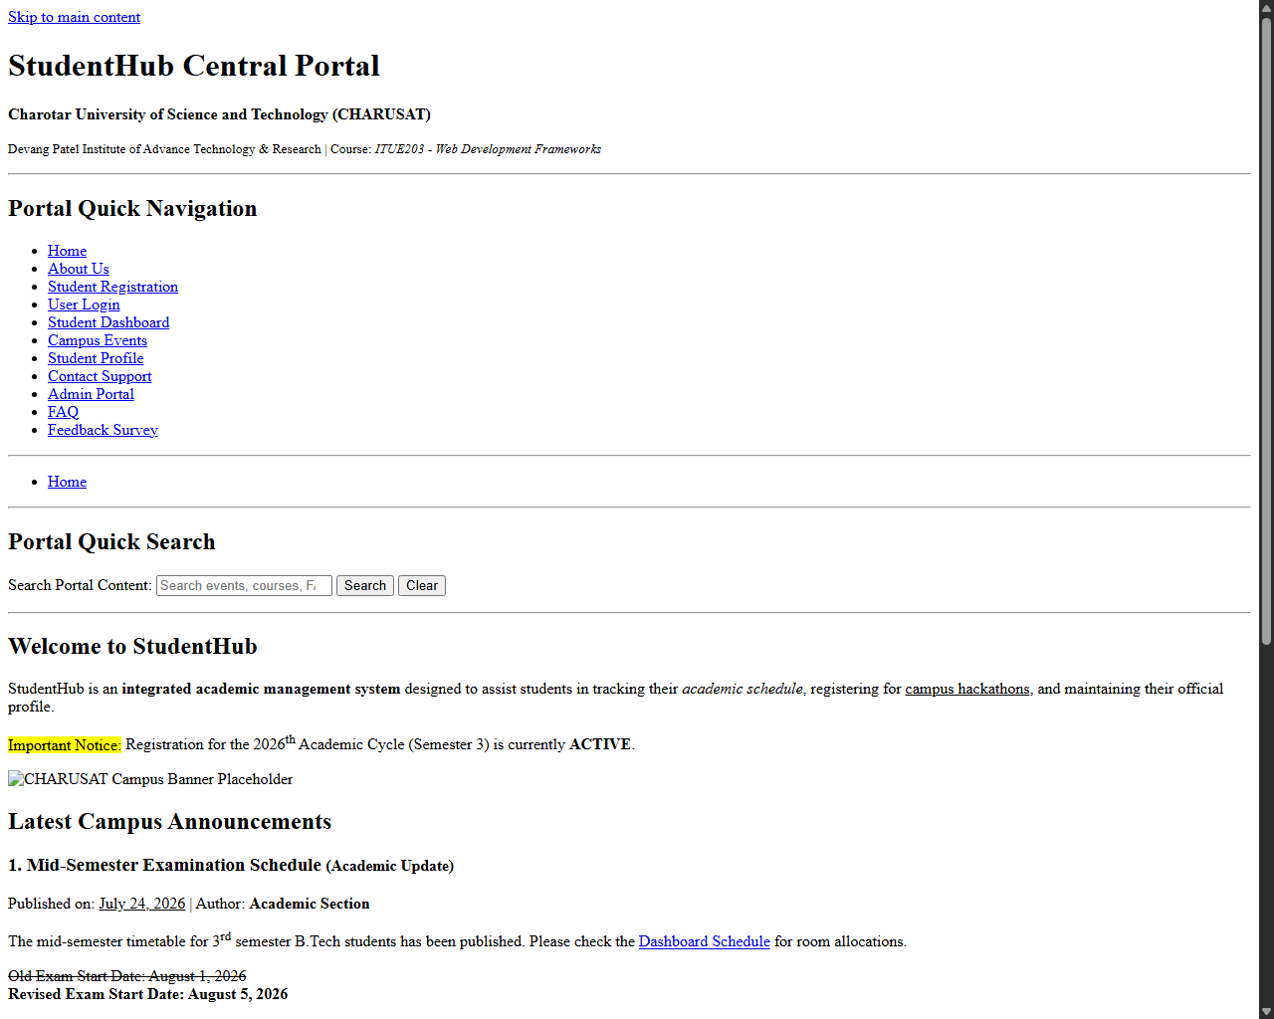
Figure: Browser output screenshot for Home Page

Webpage Output - About Us Page (about.html)
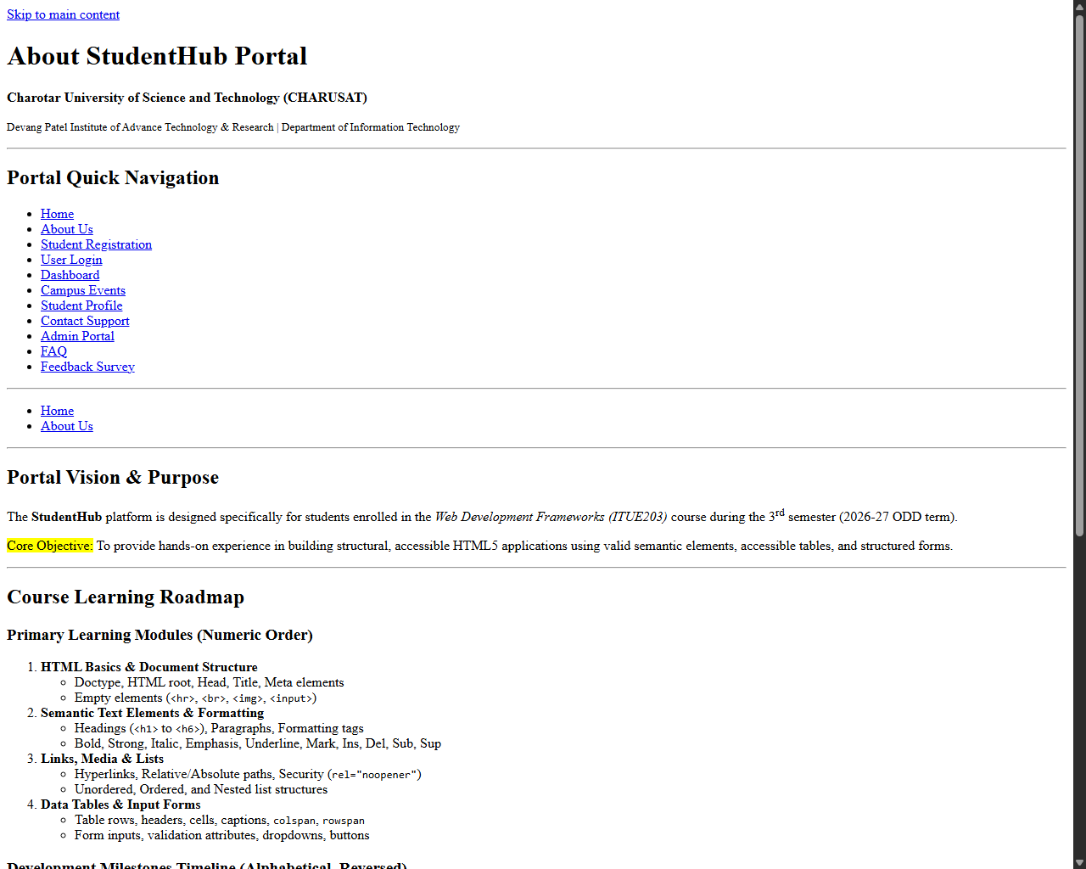
Figure: Browser output screenshot for About Us Page

Webpage Output - Student Registration Page (register.html)
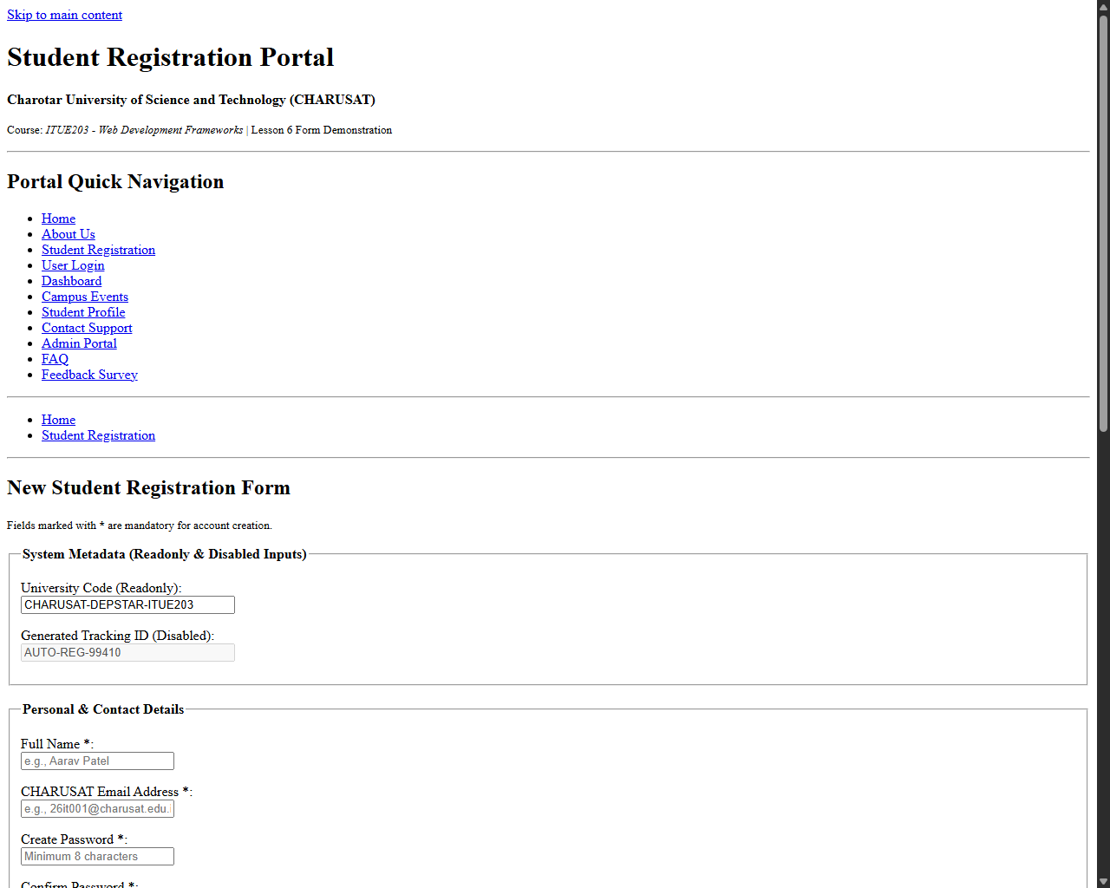
Figure: Browser output screenshot for Student Registration Page

Webpage Output - User Login Page (login.html)
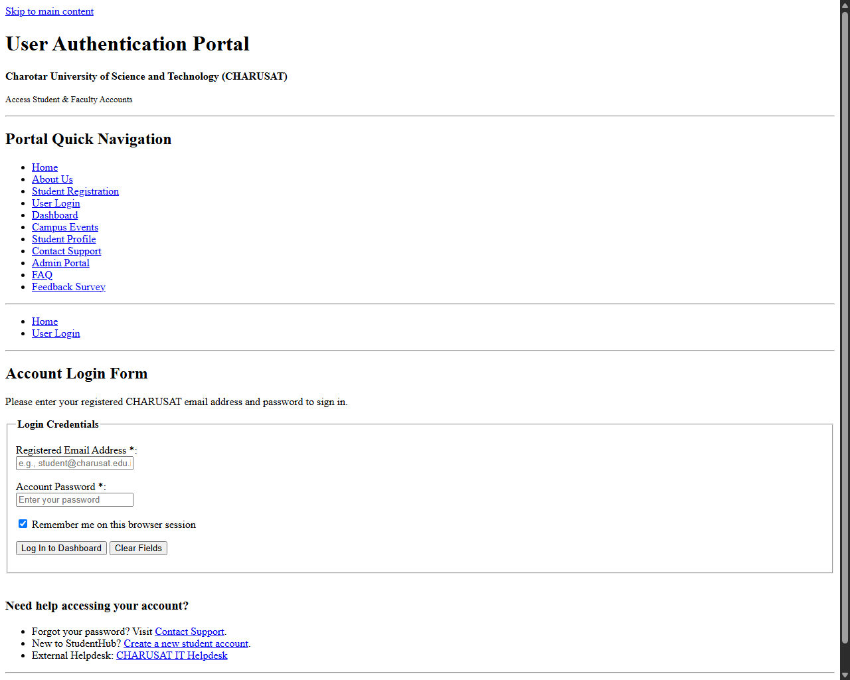
Figure: Browser output screenshot for User Login Page

Webpage Output - Student Dashboard Page (dashboard.html)
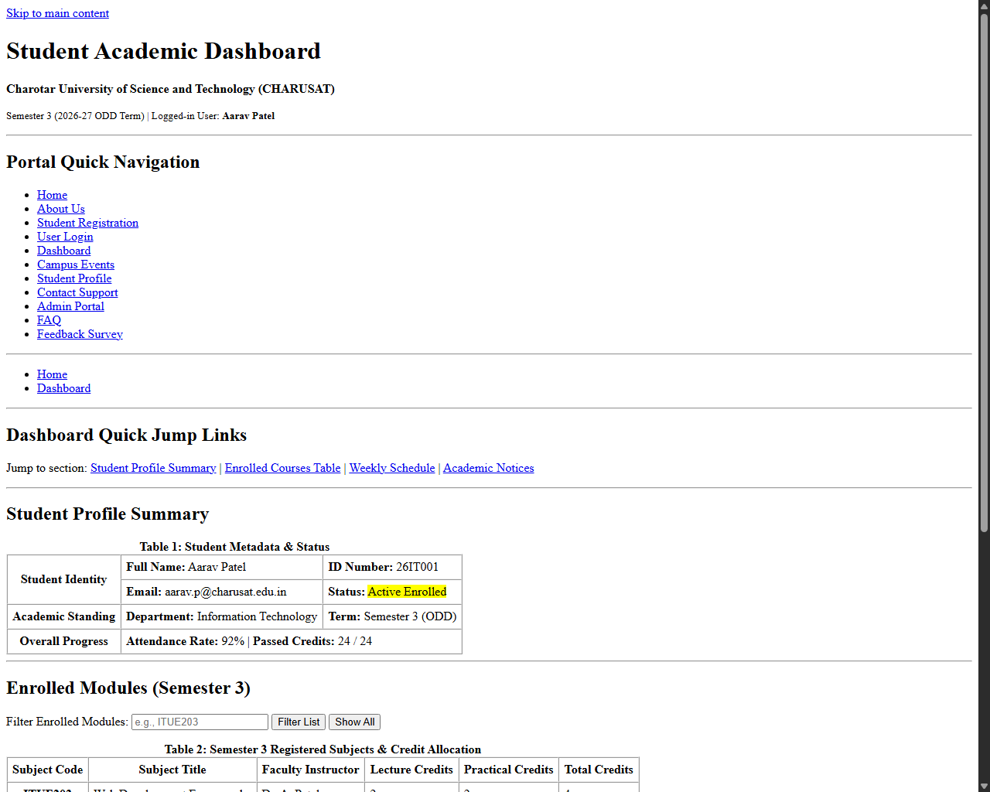
Figure: Browser output screenshot for Student Dashboard Page

Webpage Output - Campus Events Page (events.html)
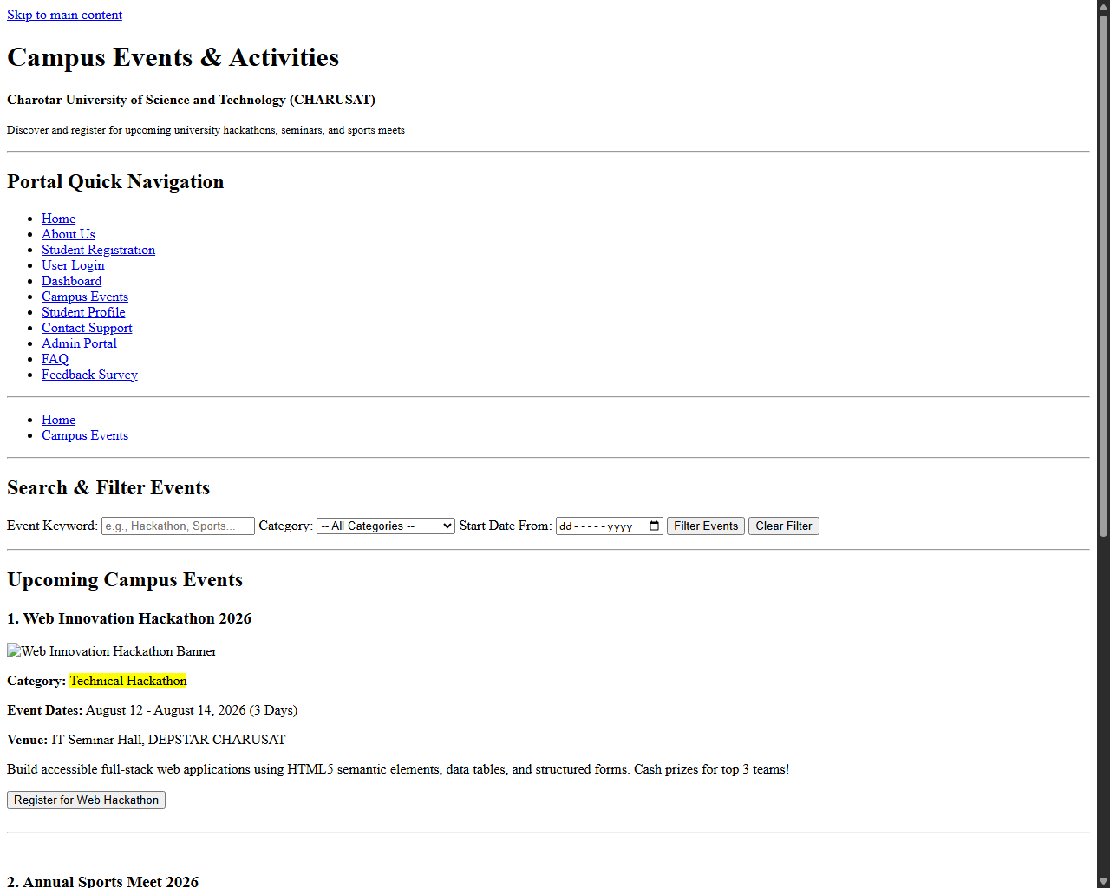
Figure: Browser output screenshot for Campus Events Page

Webpage Output - Student Profile Page (profile.html)
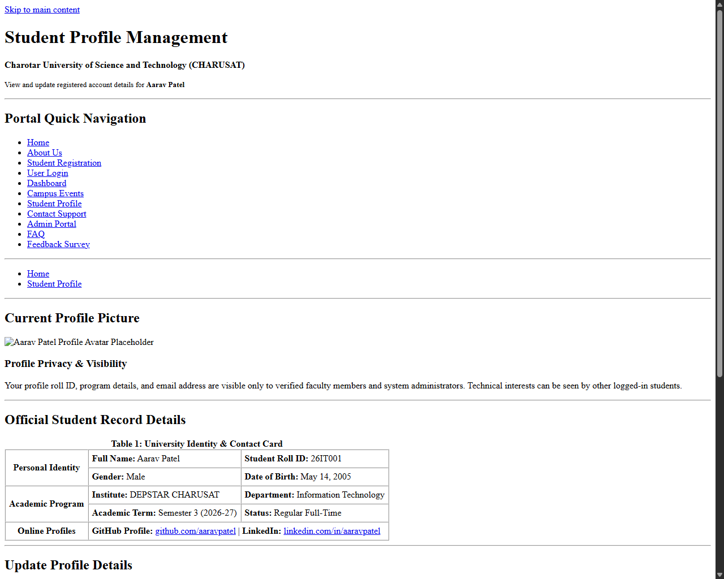
Figure: Browser output screenshot for Student Profile Page

Webpage Output - Contact Support Page (contact.html)
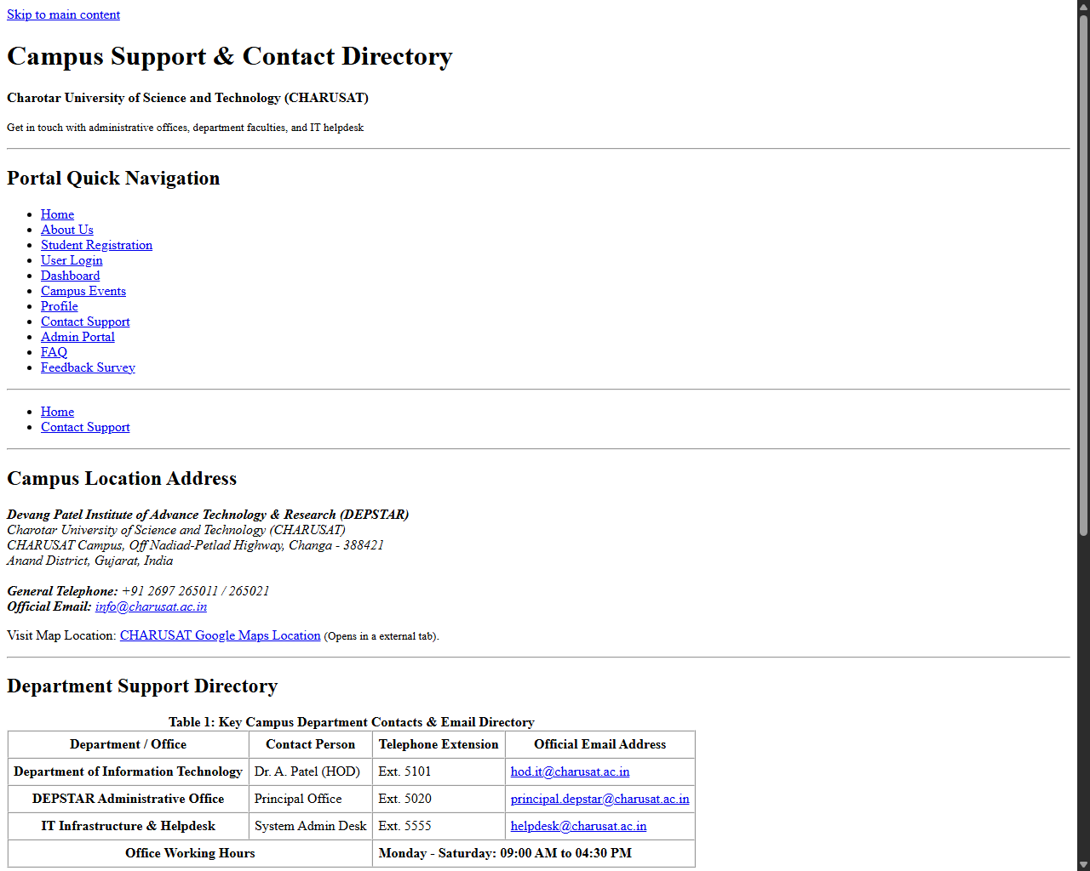
Figure: Browser output screenshot for Contact Support Page

Webpage Output - Admin Portal Page (admin.html)
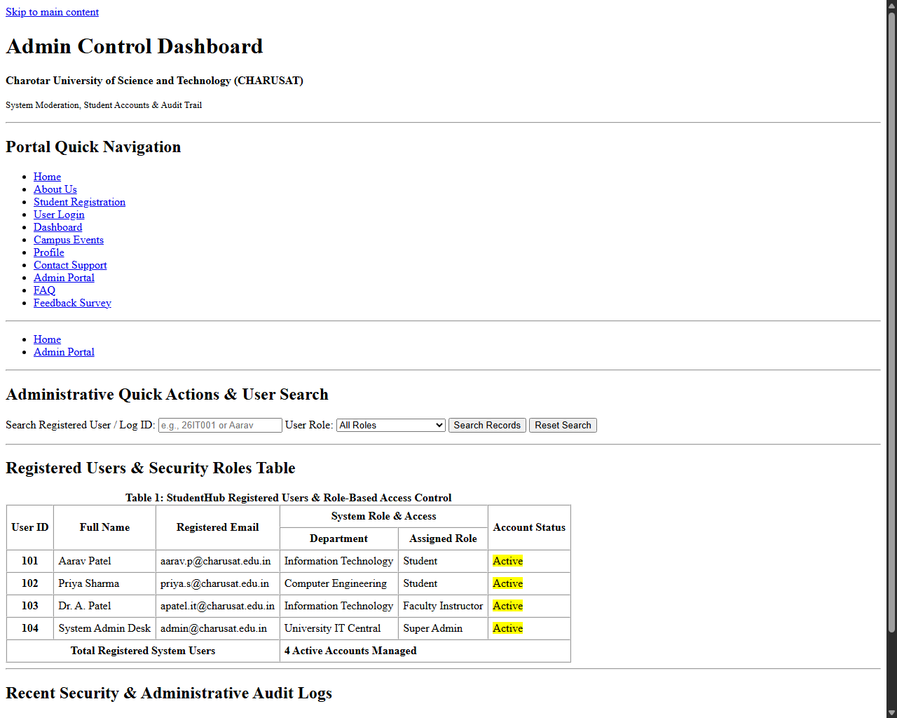
Figure: Browser output screenshot for Admin Portal Page

Webpage Output - FAQ Page (faq.html)
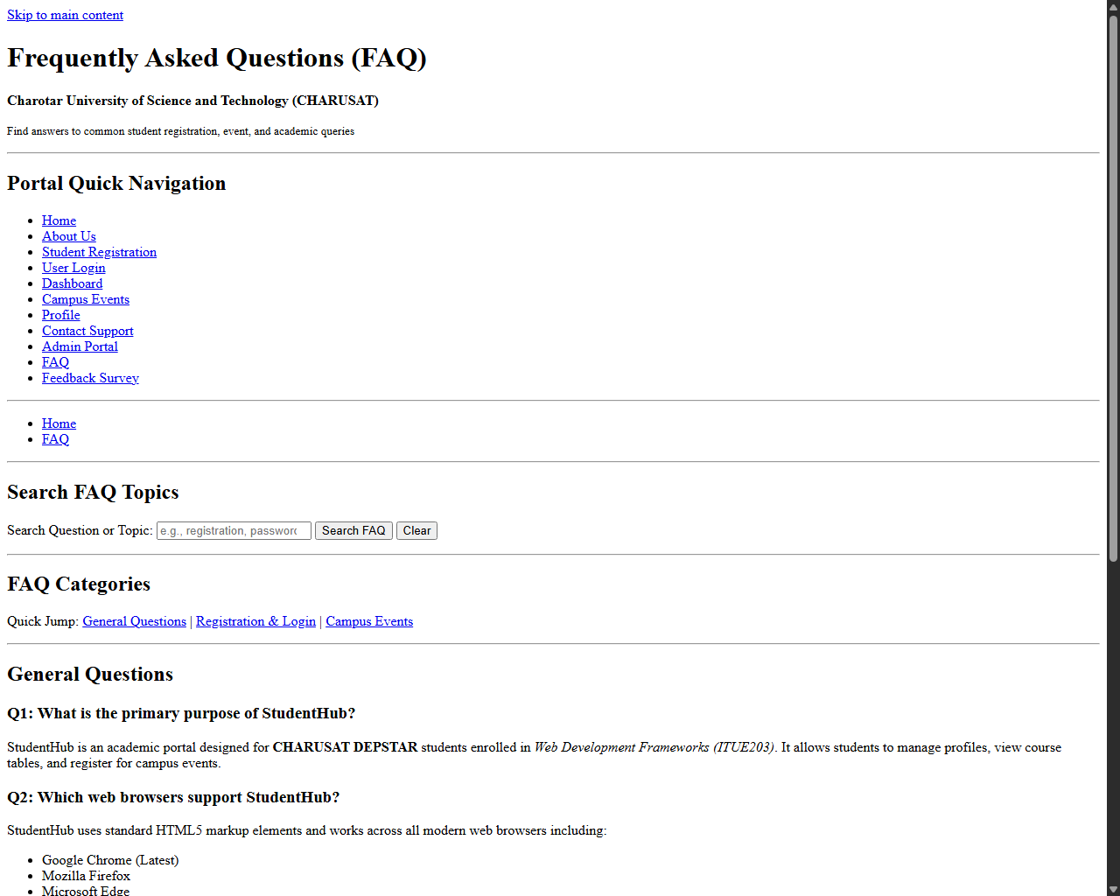
Figure: Browser output screenshot for FAQ Page

Webpage Output - Feedback Survey Page (feedback.html)
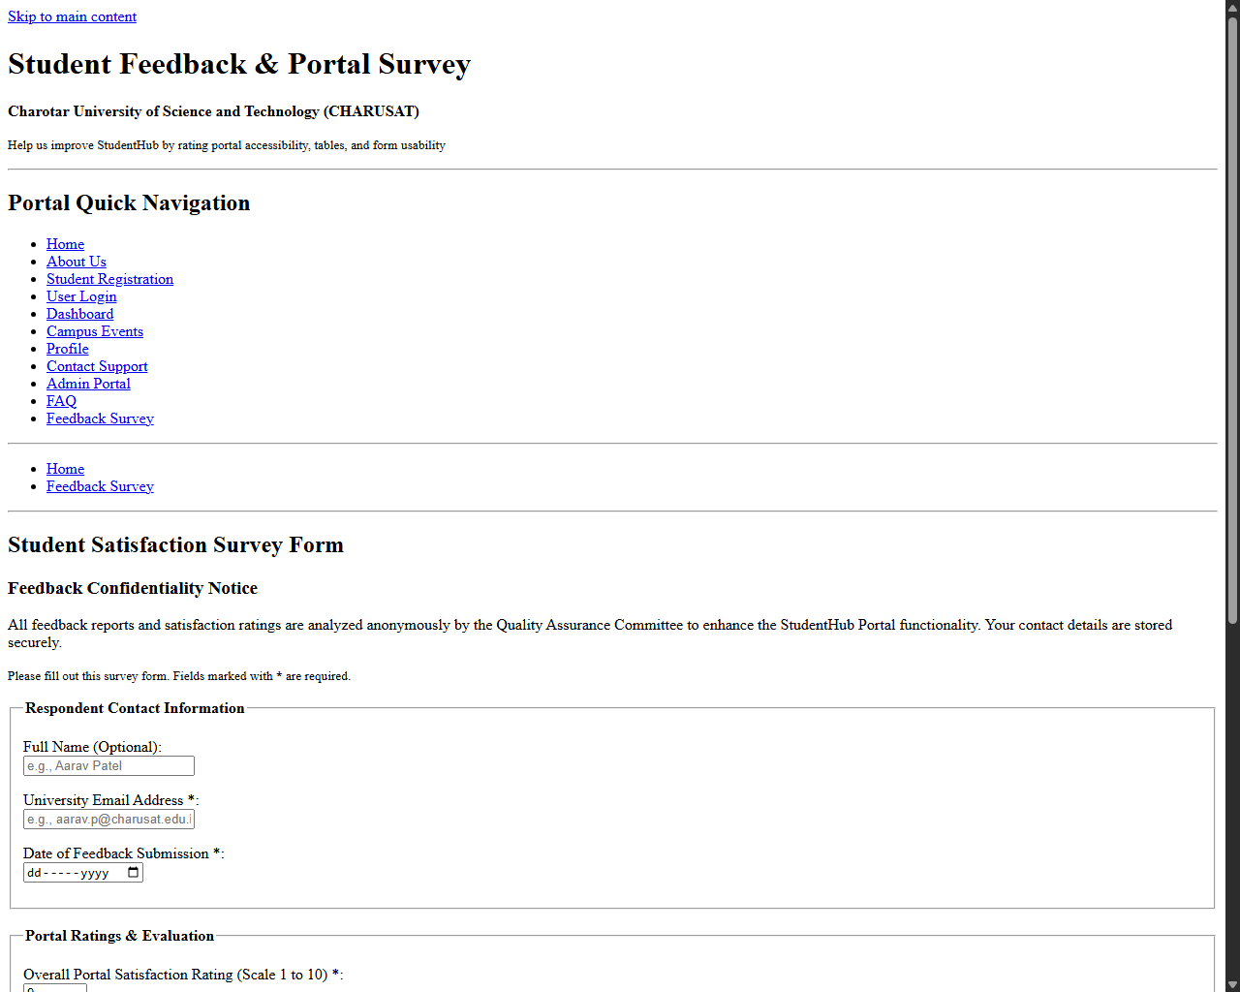
Figure: Browser output screenshot for Feedback Survey Page

